FRESH BITES CATERING

Report

1.INTRODUCTION:

1.1.Overview:

Fresh Bites Catering, a catering service, utilizes Zoho Books to manage their sales, track inventory, and handle invoicing. They can generate professional invoices for clients and track expenses related to ingredients and supplies. Zoho Books helps them maintain accurate financial records and streamline their catering operations.

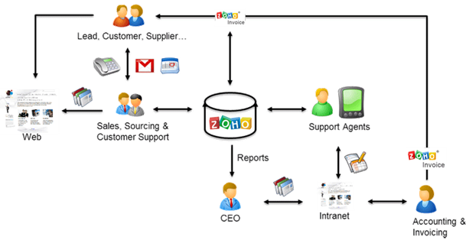

1.2 Purpose:

Fresh Bites Catering, a catering service, utilizes Zoho Books to manage their sales, track inventory, and handle invoicing. They can generate professional invoices for clients and track expenses related to ingredients and supplies.

USAGE: Zoho Books is your one-stop platform for managing your accounting tasks and organizing your transactions. It's a single secure location to keep up with your company's bills and invoices, reconcile your bank statements, control your spending, oversee projects, and eliminate GST compliance worries.

PROBLEM DEFINITION & DESIGN THINKING:

* Improving Customer Service. ...
* ZOHO streamlines Customer's Grievance Redressal. ...
* Measuring the Business Impact. ...
* Improves Collaboration Between Teams. ...
* Access Data At Any Time and From Anywhere.

EMPATHY MAP:

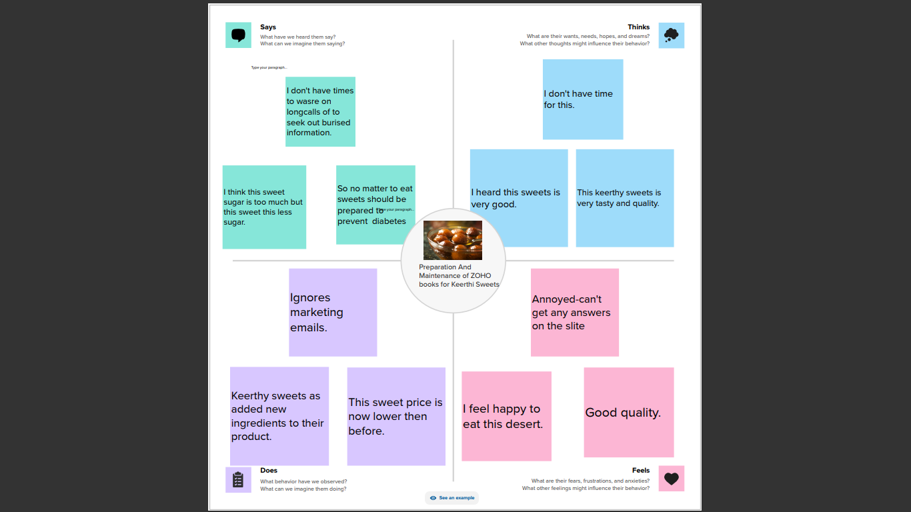

2.2.IDEATION & BRAINSTORMING MAP:

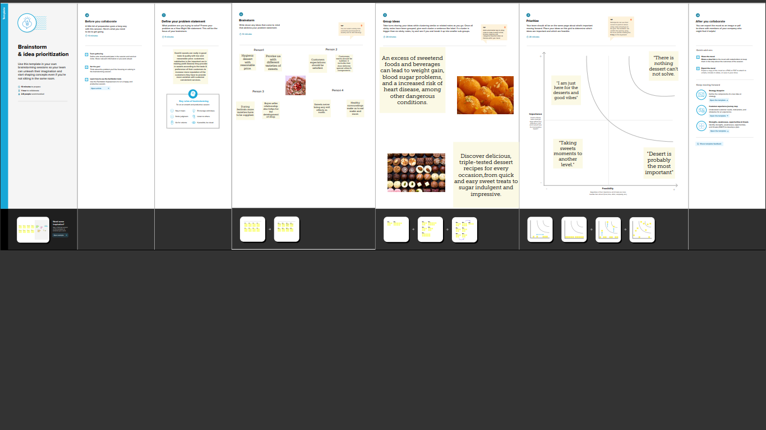

3.RESULT:

OUTPUT:

1.COMPANY NAME:FRESH BITES CATERING(FLARENS JERI)

i) ITEM CREATION:

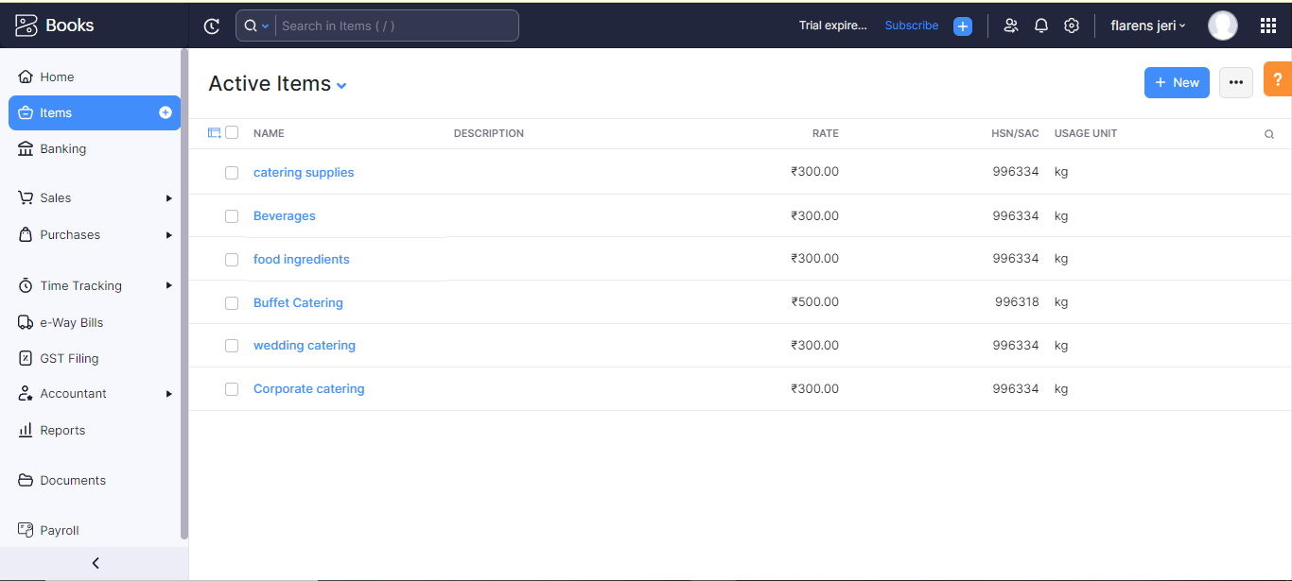

ii) VENDOR CREATION:

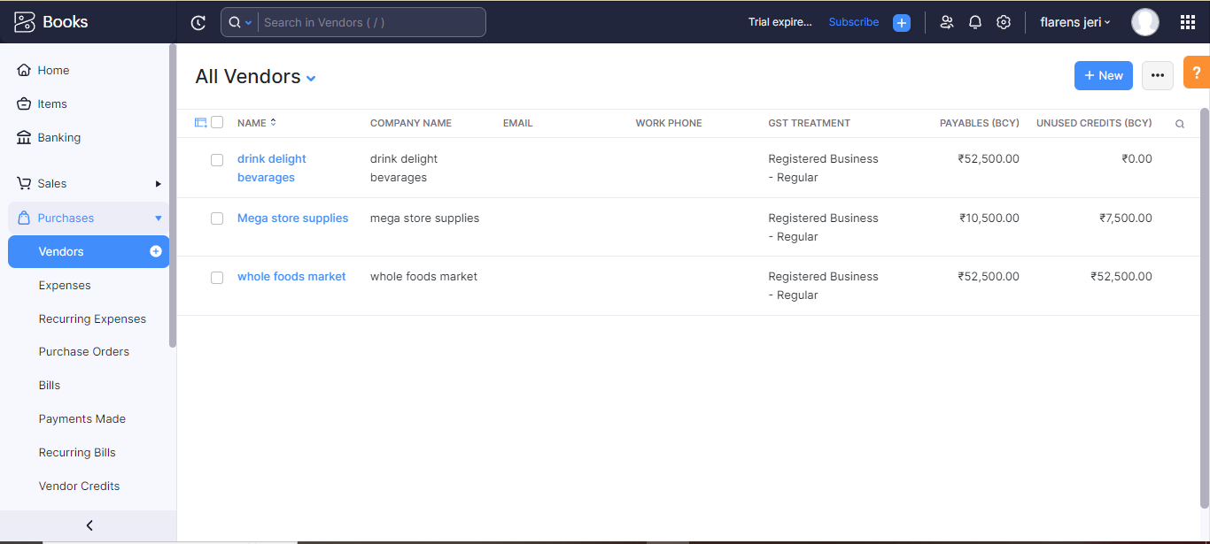

iii)PURCHASE ORDER:

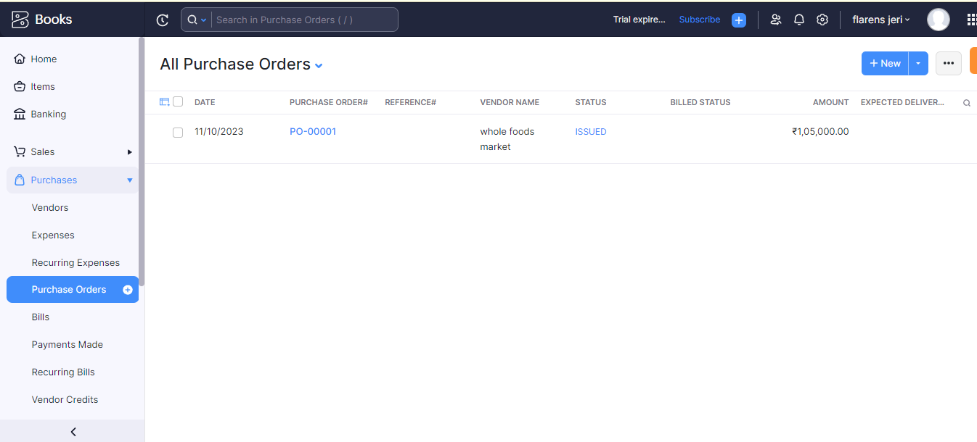iv)SALES ORDERS:

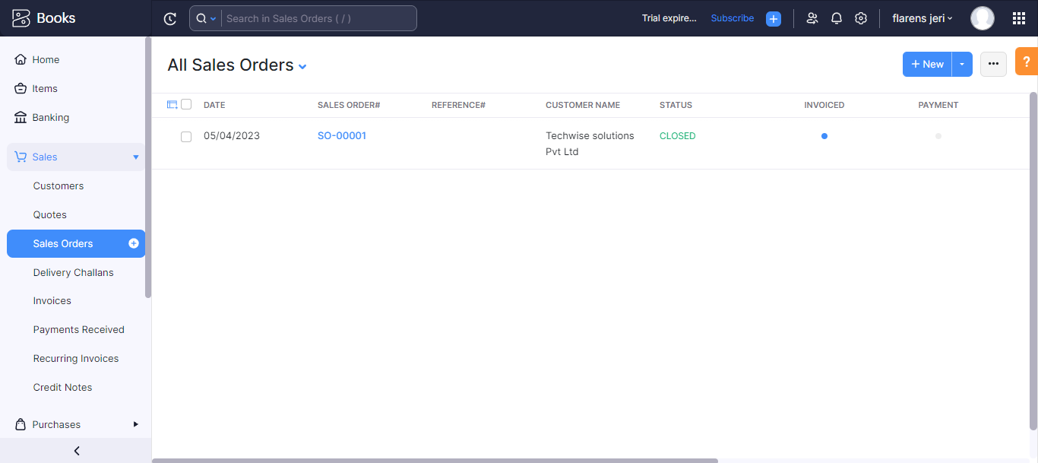

V) ICICI BANK TRANSACTIONS:

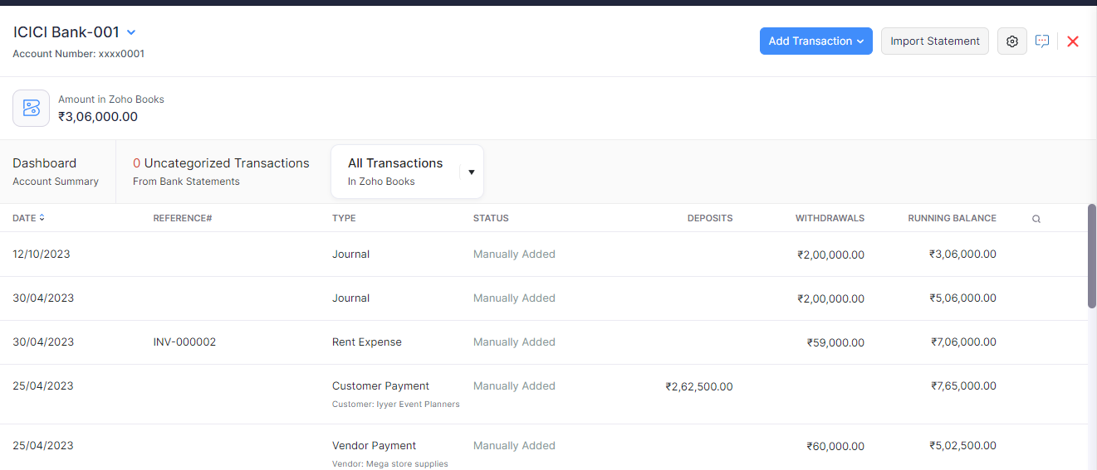

Vi) PROFIT & LOSS ACCOUNT:

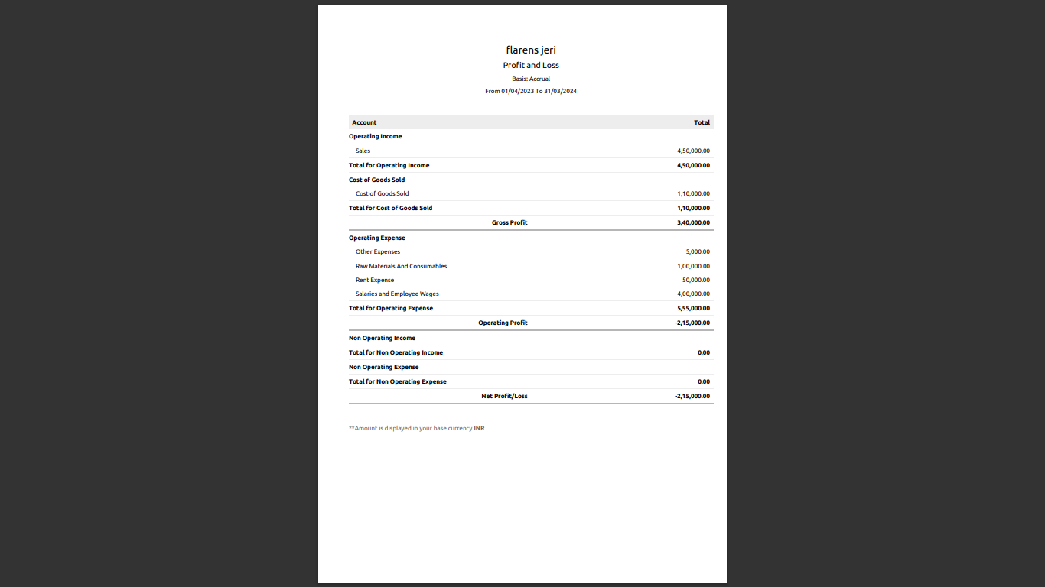

Vii) GST:

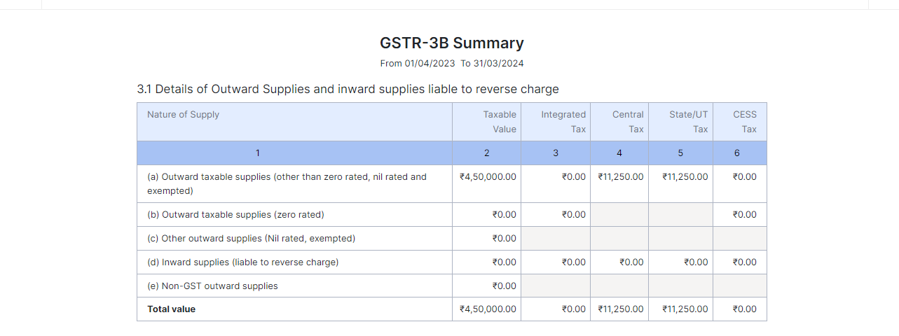

Viii) BALANCE SHEET:

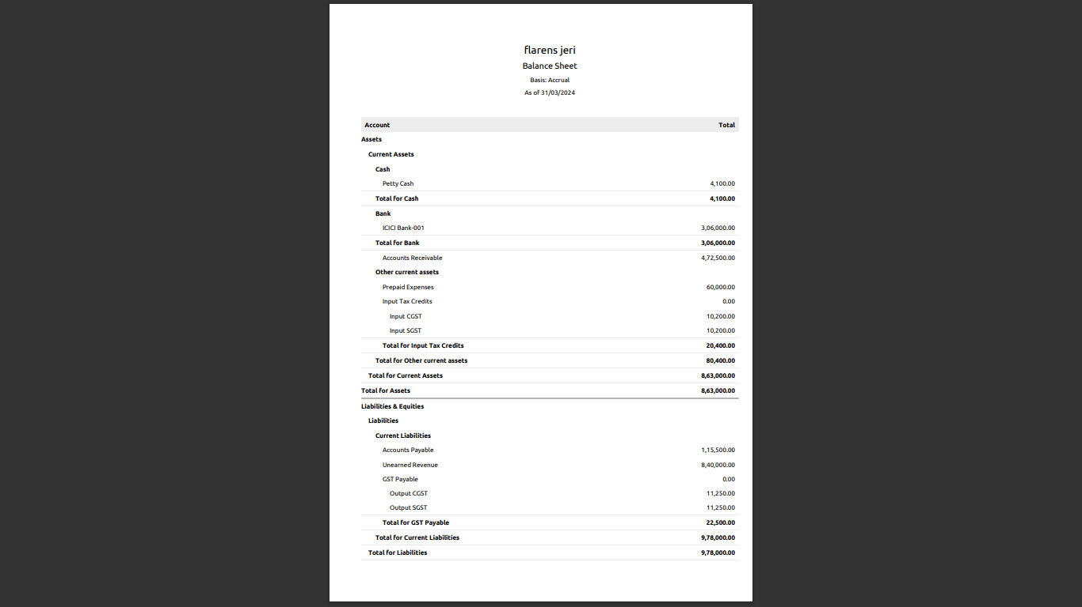

4.ADVANTAGES & DISADVANTAGES:

* Monthly transaction cap. ...
* Multiple subscriptions for multiple businesses. ...
* Additional users require a fee. ...
* Fewer integrations than competitors. ...
* No payroll services. ...
* Accounts payable limitations.

5.APPLICATIONS:

Manage accounting on the go with ZOHO books ios and Android apps. Do your accounting on the go using the mobile app for ios,android ,and windows.

5.CONCLUSIONS:

ZOHO BOOKS PROVIDES FUTURE TECHNOLOGIES FOR GOING ON BUSINESS AND SUPPORTS STUDENTS PROJECT . IT IS EASY TO USE AND ACCESS TOO.

6.FUTURE SCOPE:

Preparing and storing food safety before during events,setting up all tablets and food services areas with chairs,lines and dishes,servicing food to guets at accounts.events. It also helped to reduce the work of the accountant to

7.APPENDIX:

A.SOURCE CODE: COMPUTER DATA

i)Approved developments

ii)Future assessment

iii)Plan of development

iv)Convactions free delivery and pickup.

EMPATHY MAP & BRAINSTORM:

<https://github.com/mtu121ucom019/preparation-and> mainteance-of-ZOHO-BOOKS-for-keerthi/commit/98c5ff7a09b2c0c9d2f39ccf638d3cb20ebcbd

ZOHO BOOK LINK:

Zoho.books.com